LOKRITE Break out Procedure: INDIVIDUAL UNIT

Tension release bolt should be run up until the head of the bolt is touching or close to the Lokrite tool.
(This is for all sizes of Lokrite units including openend and Boxend style)
The head of the bolt will hit the reaction point.
Example below:
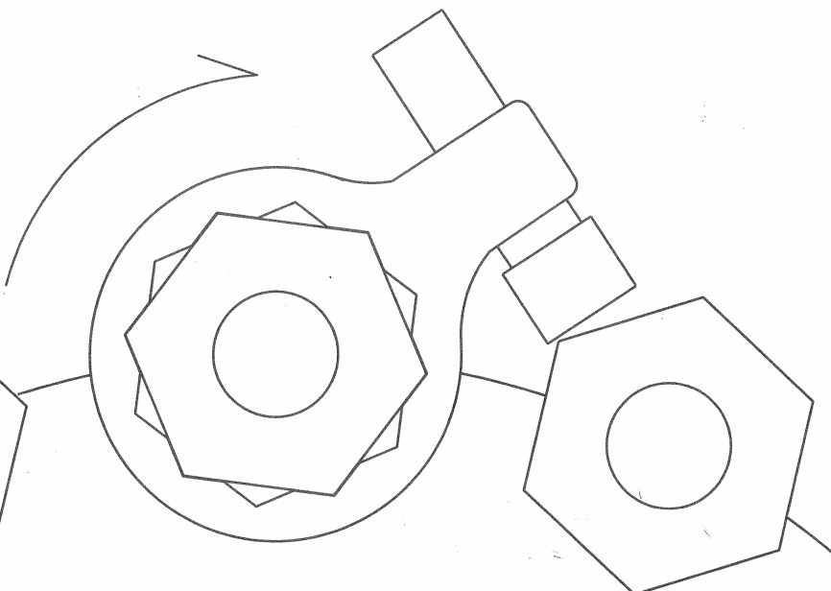

Set Lokrite unit in place on nut with the label facing out.
Let unit rotate during applied torque until tension release bolt Head contacts reaction point (Normally nut on clock-wise side).
After torque is applied nut will be loose.
Take unit off and proceed to next nut.
(It is not recommended to use impact wrench for breakout. Use torque wrench only, hydraulic or pneumatic.)

